Project Report
GLOBAL EARTHQUAKE-TSUNAMI RISK PROBABILITY CLASSIFIER
Sakshat Apoorva Joshi
25BAS10038

2. Introduction
This project focuses on applying foundational Machine Learning principles to a real-world geophysical problem: predicting the probability of an earthquake generating a tsunami. Leveraging seismic data, we developed a classification model to provide rapid, data-driven risk assessment, which is crucial for modern early warning systems. The entire workflow, from data acquisition and training to evaluation and visualization, was implemented within the Google Colab environment.

3. Problem Statement
Manual analysis of seismic event data (magnitude, depth, location) to determine the likelihood of a resultant tsunami is slow and often heuristic-based. The challenge is to build a robust, simple, and automated system that can analyze the key physical characteristics of an earthquake and classify the event as Tsunami (1) or No Tsunami (0) with high accuracy, thereby reducing decision latency in mission-critical scenarios.

4. Functional Requirements
The system is divided into three distinct functional modules:
- Data Acquisition & Preparation: Must successfully download the required dataset, handle missing data, and perform the essential Machine Learning preparation steps (train/test split and scaling).
- Logistic Regression Training Engine: Must train the Logistic Regression model using the scaled training data and output key performance metrics (Accuracy, Precision, Recall) upon testing against unseen data.
- Prediction & Visualization: Must use the finalized model to predict the tsunami probability for all events and generate a clear visualization of the classification results based on the key features.

5. Non-functional Requirements
The following non-functional requirements were established for the system:
- Accuracy (Reliability): The model must achieve an Accuracy Score exceeding 80% on the unseen test set to be considered reliable for initial risk screening. (Achieved: 82.65%)
- Usability: The entire project workflow must be contained within a single, executable Google Colab Notebook for ease of replication and testing.
- Maintainability: The project utilizes only common Python libraries (scikit-learn, pandas) and clear, modular code structure for easy understanding and updates.
- Security (Data): The data acquisition process requires user-specific credentials (Kaggle API key), ensuring data is accessed via authorized channels.

6. System Architecture
The project follows a linear, three-module pipeline architecture executed sequentially within the Google Colab runtime:
- Input Layer: Kaggle Dataset API (via opendatasets).
- Processing Layer (Section 2): Data cleaning, feature scaling, model training, and evaluation (Logistic Regression).
- Output Layer (Section 3): Final predictions, evaluation metrics, and Matplotlib visualization.

7. Design Diagrams
7.1 Use Case Diagram
The primary user interaction is simple, focusing on the core ML workflow components:
- User: Runs Data Acquisition, Runs Model Training, Views Evaluation Metrics, Views Visualization.
7.2 Workflow Diagram
(Placeholder for a simple flow chart: Start -> Data Download -> Clean/Scale -> Train/Test Split -> Train Model -> Predict -> Visualize -> End)
7.3 Sequence Diagram
(Placeholder for a sequence diagram detailing the steps in Section 2: Data -> Scaler -> Model -> Prediction -> Metrics Calculation)

8. Design Decisions & Rationale
The key design decisions were:
- Model Choice (Logistic Regression): Chosen because the target (tsunami) is binary (0/1), making it a classification problem. Logistic Regression is the simplest, most interpretable model that outputs a probability, satisfying the requirement for foundational ML application.
- Feature Selection: The features Magnitude and Depth were chosen as primary indicators, supported by Latitude and Longitude to account for tectonic plate boundaries, which are crucial for tsunami generation.
- Evaluation Metric: Accuracy was used for high-level validation, but the Recall for Class 1 (Tsunami) was prioritized as the most critical metric for safety (minimizing missed tsunamis).

9. Implementation Details
The project was implemented in Python using the Scikit-learn library.
- Features (X): ['magnitude', 'depth', 'latitude', 'longitude']
- Target (y): tsunami
- Preprocessing: Standard Scaler was used to normalize features, which is essential for the convergence of Logistic Regression.
- Training Split: A 80/20 train-test split was used (test_size=0.2) with stratify=y to ensure the test set accurately reflects the imbalance of tsunami events in the data.

10. Screenshots / Results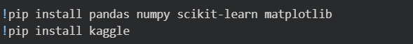
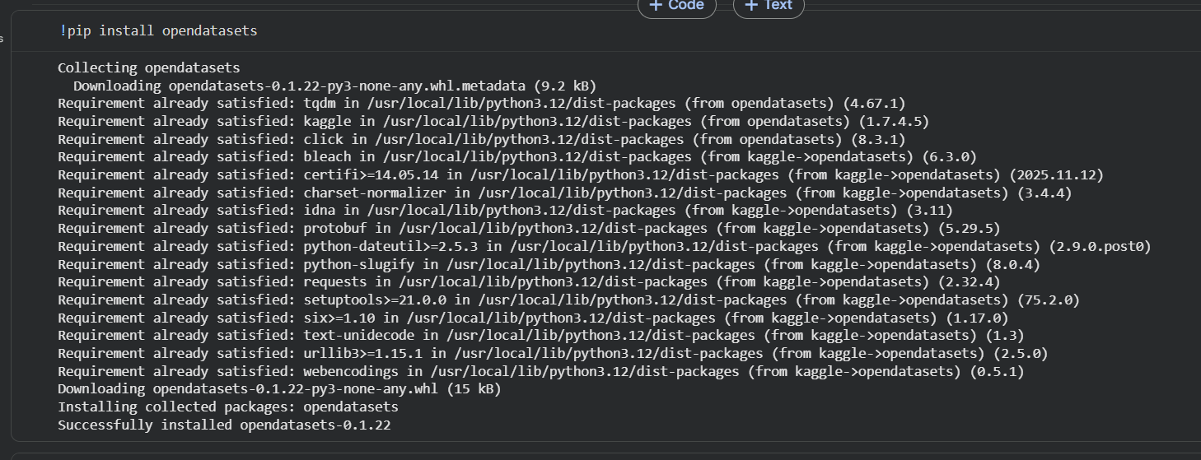
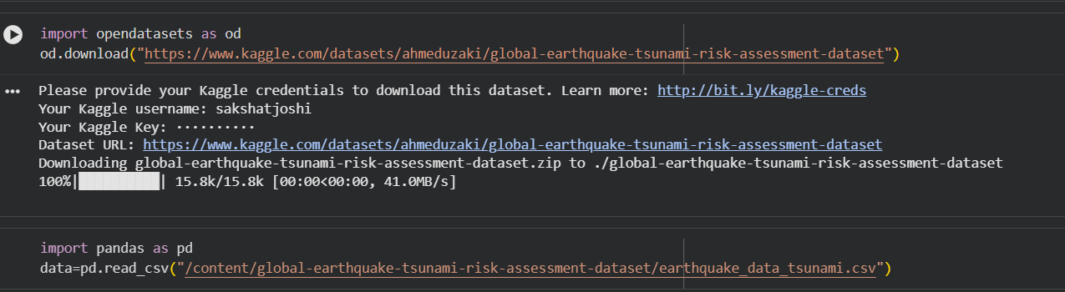
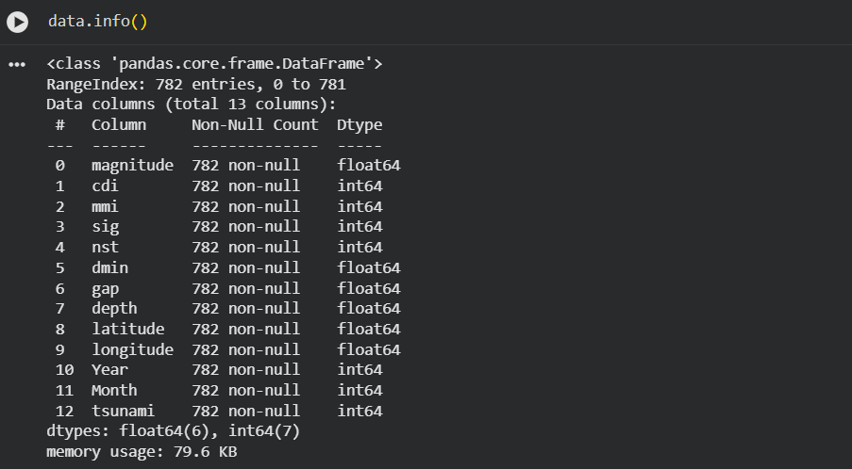
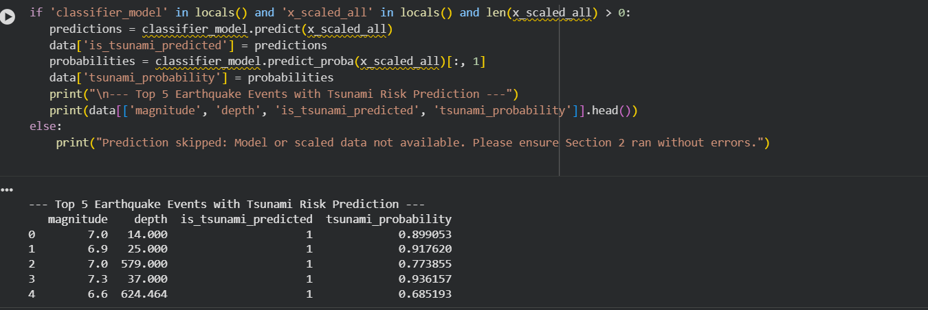
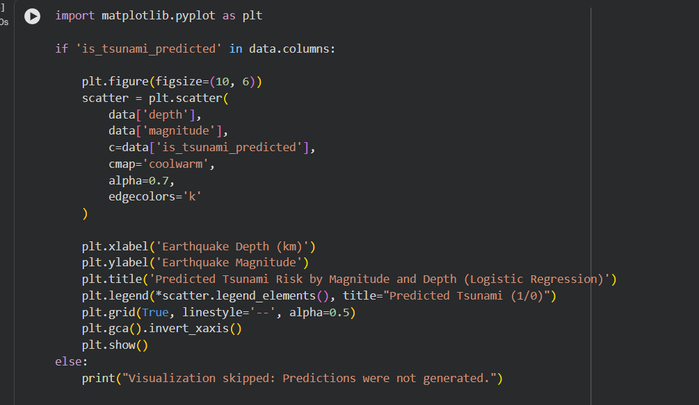
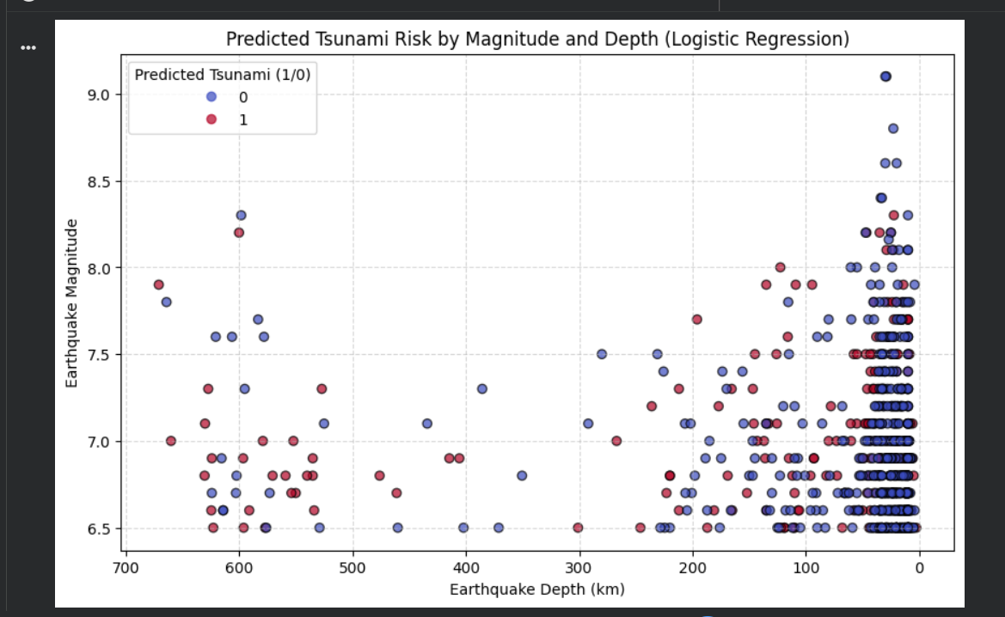
11. Testing Approach
The project employs a standard Hold-out Cross-Validation method:
- The dataset was split into a 80% Training Set and a 20% Test Set using train_test_split.
- The model was trained exclusively on the 80% training data.
- The model's performance was then evaluated entirely on the unseen 20% Test Set.
- The success criteria were met by observing an Accuracy Score of 82.65%, confirming the model's ability to generalize to new, independent earthquake events.

12. Challenges Faced
- Data Acquisition: Initial difficulties arose with API authentication (403 Forbidden error) when attempting to use the raw Kaggle API, necessitating a switch to the more robust opendatasets library for seamless integration.
- Model Suitability: Ensuring the correct model was used; Linear Regression was initially considered but was immediately replaced by Logistic Regression to correctly handle the binary classification nature of the problem.
- Feature Scaling: Overcoming the requirement to scale the data using StandardScaler to prevent convergence issues in the Logistic Regression algorithm.

13. Learnings & Key Takeaways
- Classification vs. Regression: Reinforced the critical difference between classification and regression and the importance of selecting models appropriate for the target data type (binary vs. continuous).
- Importance of Scaling: Learned that for distance-based or coefficient-based models (like KNN or Logistic Regression), Feature Scaling is a mandatory pre-processing step to prevent features with larger ranges (like Depth) from unduly influencing the model's output.
- Real-World Metrics: Gained practical experience analyzing metrics crucial for safety systems (Precision and Recall) beyond simple Accuracy.

14. Future Enhancements
- Hyperparameter Tuning: Implement Grid Search or Random Search to find the optimal hyperparameters for the Logistic Regression model to potentially increase the prediction accuracy further.
- Advanced Features: Incorporate additional geological features, such as the Fault Type (Categorical) and the Proximity to Coastal Population Centers, for a more nuanced risk assessment.
- Model Comparison: Compare the performance of Logistic Regression against other simple classifiers like Support Vector Machines (SVM) or Random Forest.

15. References
- https://www.kaggle.com/datasets/ahmeduzaki/global-earthquake-tsunami-risk-assessment-dataset
- Pedregosa et al. (2011). Scikit-learn: Machine Learning in Python. JMLR 12.

